CAS PY 106

Prelecture Note 17

1. Likes Attract
2. Much like two charged particles, two parallel wires can attract or repel, depending on the direction of their currents
3. Magnetic field on a wire is

B = u\*I/2pi(r)

1. Force on wire 1 given to wire 2 is:

F12=I2\*L\*B1

1. Since the wire length is known as infinite, we measure force per length:

F12/L=I2\*B1

1. Combining two equations we get:

F12/L = I2\*I1\*u/2pi(r)

1. Direction of the force
2. 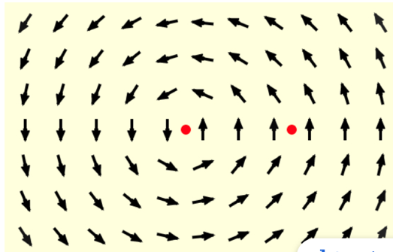
3. In the example above, field is created by wire on the left, which carries current out of the page.
4. To find direction of the field, we use right-hand rule in which we point thumb on our right hand in the direction of current and curl our fingers
5. The fingers show that the field curls counterclockwise
6. Determine the direction that second wire feels due to the first wire.
7. At the location of the second wire, the field is directed up and we used the F=ILB right hand rule.
8. The force goes to the left, showing that these two wires attract one another
9. In contrast to electric charge, with parallel current-carrying wires we see that likes attract, and unlike repel
10. Parallels with point charges
11. 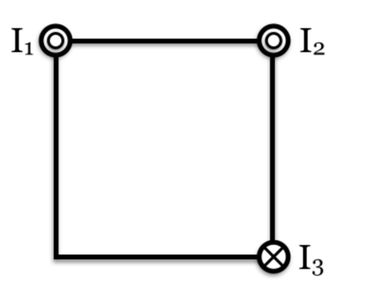
12. Cross-sectional view through a set of three long straight wires, each wire passing through a different corner of a square
13. Long straight wires we can ask about the net field at a particular point
14. We can also ask about net force one wire feels because of the other two
15. Ex) if all three currents have the same magnitude, in which direction is net force on wire 2?

45degrees up and to the left (attracted to I2 and repelled from I3)

1. Ex) two parallel current-carrying wires, each carrying a current of 1A and with distance 1m between them. What is magnitude of the force per unit length experienced by each wire?

F = I1\*I2\*u/2pi(r)

= 1\*2\*10^-7/1

= 2\*10^-7 F/L

1. If you want to increase the force per unit length to be 1 and reduce distance to 2.0cm, what should each current be?

F = I1\*I2\*u/2pi(r)

1 = I^2 \*2\*10^-7/.02

.02/2/10^-7 = I^2

I = 316.23A